# Importance of cost estimation

The reason for making an accurate and detailed estimate on project costs when working with a client/stakeholder is to help them determine if your offer is the most cost effective solution and that you are the most suitable person who understands their vison. the more accurate and detailed your estimates are the more chance you will win bids for contracts and increase profits in your business, however that does not mean you always underestimate your costs to win bids, you still need to make sure that you adjust your costs accordingly in order to make a respectable profit for your company. Furthermore you do not want to over-estimate your cost either as you are still in competition with over companies who want the contract.

Clients tend to want more work done while paying less for it and a contractor would want to do less work while getting paid more. That is why it is very important to find a balance between you and the client.

## Project cost techniques

Project estimations can be a stressful and scary process thinking of it as almost a life line for a company, getting them right is crucial. Stakeholders will only authorize a budget if they know that the estimates are established in a credible way. There are techniques in place which can make it more bearable to work out these costs. I will try to name and explain each technique briefly to get a good understanding of what they do, furthermore I will write the advantages and disadvantages of each one. Here are the 4 most popular techniques used today.

**Top-Down estimation** – The top-down approach is a useful technique in the early phase of a projects it provides the client a ball park estimate which in turn helps decide whether the proposed client offer is sufficient in the completion of the project. It involves deciding the total cost of the project then splitting it between the phases in the project to see if it will equally cover each one. There are arguments that this approach is severely inaccurate, as you have to guess the initial total first then keep the same total for the entire project without interchanging variables also it is not team friendly as opposed to the bottom-up approach.

**Bottom-up estimation** – Similar to the Top-Down approach this technique is more accurate. The reason for this is that instead of the upper management providing project objectives, the task is given to the team who decide all the objectives and tasks. The project manager will then use that to break down each phase and task then assign a cost and calculate a total budget from that. The challenge with using this approach is that you need to know all the details about each task in order to produce an accurate estimate, this can be very time consuming as you are working on a granular level.

**Analogous estimation** – if you are a company which has carried out many projects over the years, there is a good chance that there is a project which you worked on that is similar to a current project. This approach uses comparison from previous projects and providing estimates from them. If a website that you created last year cost £50,000 to complete you can look at specific tasks in that project and see which are similar to provide an estimate. This can be argued that even though there are similarities between past projects, each project is unique and could require more resources. However this approach is quick and inexpensive and can be used for projects without much detail.

**Parametric estimation** – As the name suggests the parametric approach uses variables to create parameters for estimation. The variables are taken from previous projects similar to the analogous approach however it is more accurate as you are using a wide data set which uses statistical relationships between past variables.

# The Estimation

## Indirect costs

Firstly I need to work out the indirect costs of the project this can be the costs that the business incurs such as the rent of the premises, the utilities, software and hardware, and other fixed costs.

I have used Zoopla’s office space calculator (Zoopla, n.d.) to assess the square footage needed to house 5 employees with a small meeting room, kitchenette, small server room and a receptionist area. This will give me a reasonable estimate as I will be able to find the cost of similar offices on the market thus helping determine the daily costs of the premises. Below is a table of the values I entered which gave me an estimate.

According to (Dowse, 2015) “We find that an average of 80 to 100 square feet per person can creates a comfortable working environment.” This is between the specifications that the Zoopla office space calculator uses which means it’s a good source.

|  |  |  |  |
| --- | --- | --- | --- |
| Description | Dimension | Number of | square footage |
| Standard workspace Generous use of space | 95 sq. feet per person | Employees 5 | 475 sq. ft. |
| Small meeting Up to 8 people | 120 sq. feet | Rooms 1 | 120 sq. ft. |
| Kitchenette  No seating | 100 sq. feet | Rooms 1 | 100 sq. ft. |
| Small reception 1 receptionist | 150 sq. feet | Rooms 1 | 150 sq. ft. |
| Small comms/server room Up to 5 racks | 40 sq. feet | Rooms 1 | 40 sq. ft. |
| Total space required | | | 885 sq. ft. / 82.22 sq. m |

After determining the minimum square footage required for the premises, I was able to gain a rough estimate which aided me in choosing the most suitable premises. This is the building I found on Zoopla, very suitable as the offices are already equipped with all the hardware such as desks, computers printers and anything needed for a company to run. The utilities are also covered in the price, this would be the high speed broadband provided by virgin media’s fibre optic, electricity and anything else. The hub also provides these amenities

* MANAGEMENT SUITE
* FLEXIBLE MEETING SPACE
* SOCIAL MEETING AREAS
* BIKE STORAGE FACILITY
* MALE & FEMALE SHOWERS
* COMMUNAL KITCHEN

(Zoopla)



Milburn House, Dean Street, Newcastle upon Tyne, Tyne & Wear NE1

From

£1,152 pa

(£11.75/sq. ft. pa)

The Price is represented as £11.75 per square footage per annum, I would multiply this by the minimum required square footage which equals to 10,398.75 per annum then divide it by the time of project completion 21/02/2019 till 16/05/2019 which is 2 months 26 days (85 days)

The total running cost for completing this project from start to finish would equate to £2419.96 or £28.47 per day.

## Direct Costs

Secondly I will need to figure out the direct cost of this projects, this includes labour costs, travel project-specific equipment/hardware and software.

For the labour costs I used the (Living Wage Foundation, 2018) Real living wage as it represents the true wage to live on rather than the national minimum wage.

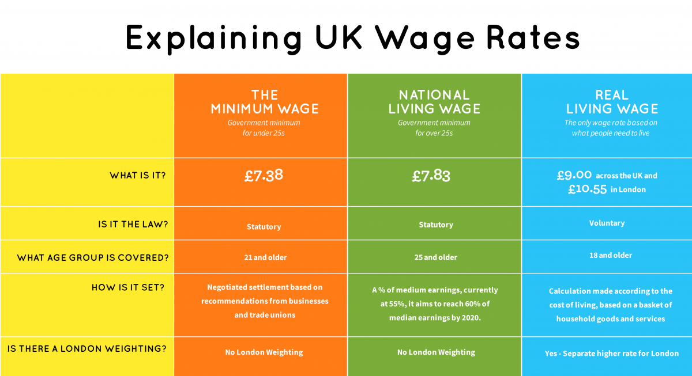

(Living Wage Foundation, 2018)

I used Microsoft Project to input all the employees in the company which are the people that will be working on the project. I set their working rate as £9.00/hr which equivalent to the suggested wage.

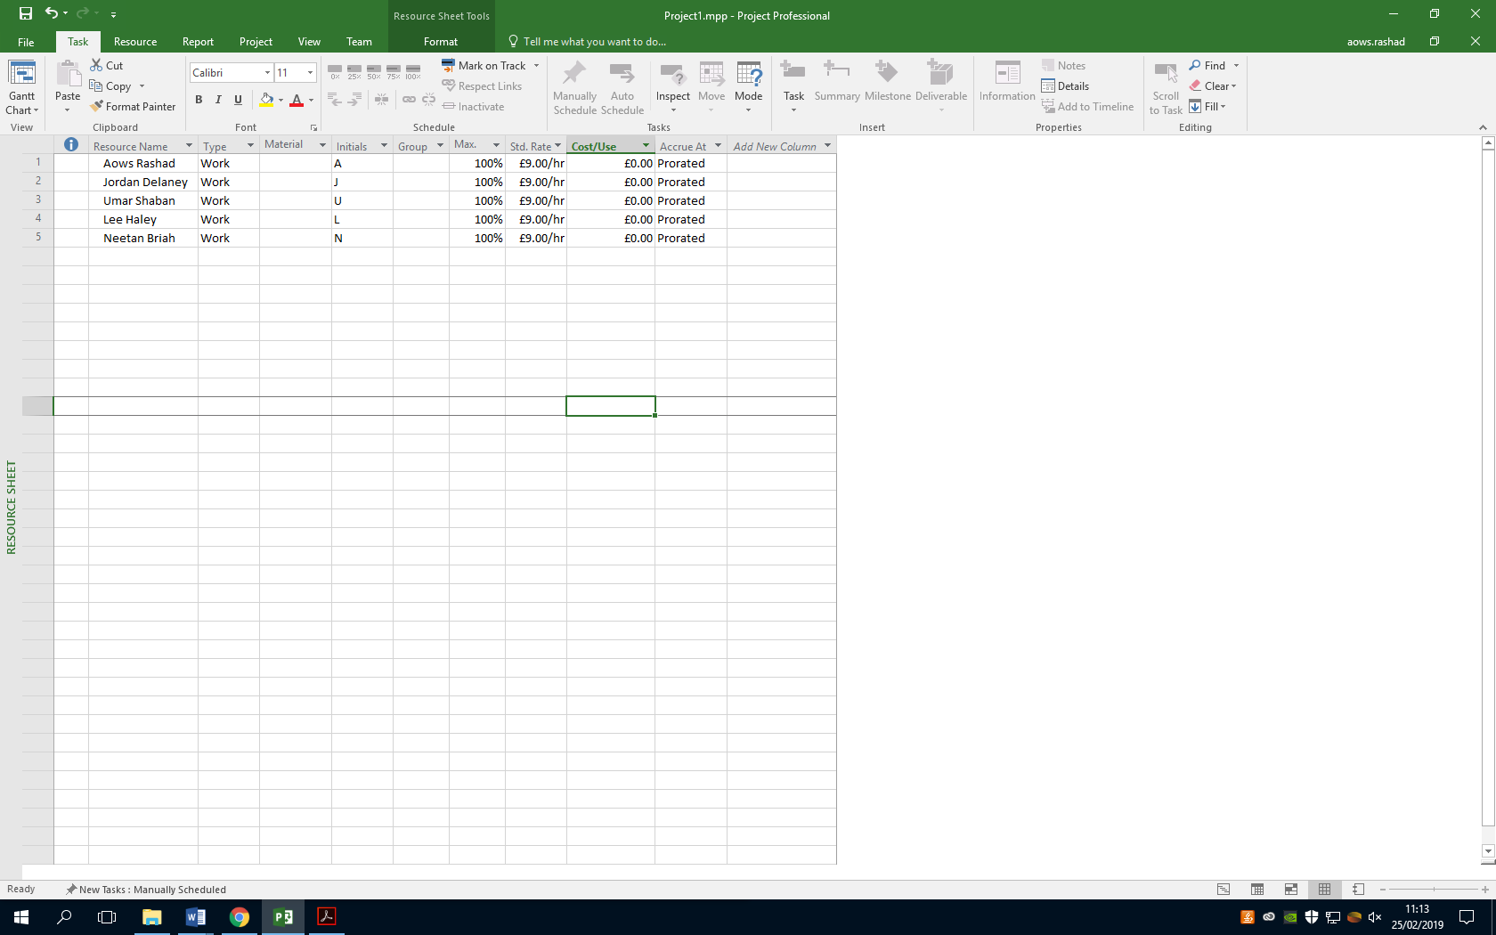

I then inputted all the tasks that the project will entail and assigned each person to a set of tasks and gave them an estimated date of completion, this game me a rough estimate of how many hours each employee will work to complete their goal. Microsoft project took care of not including non-working days such as weekends and also making sure that I don’t accidently assign an employee to two tasks thus overworking them. I then used the automated process of creating a report in which it gave me an accurate estimate of how much it will cost to pay the employees to complete the project. Another useful tool in this program is that I can choose when each task is completed and how much actual time it took them to complete it which will give me a better estimate as the project goes forward.

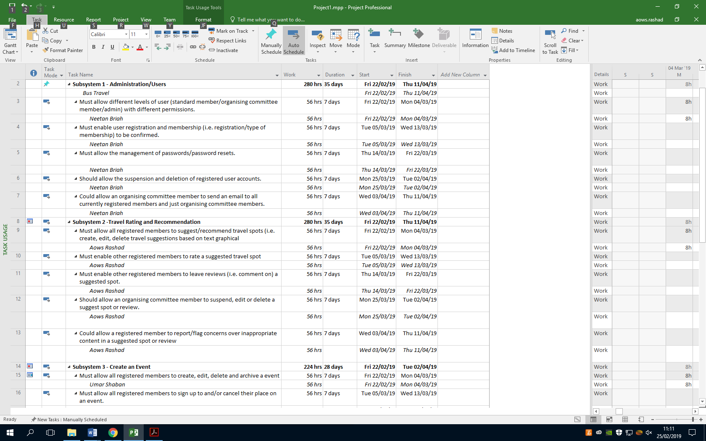

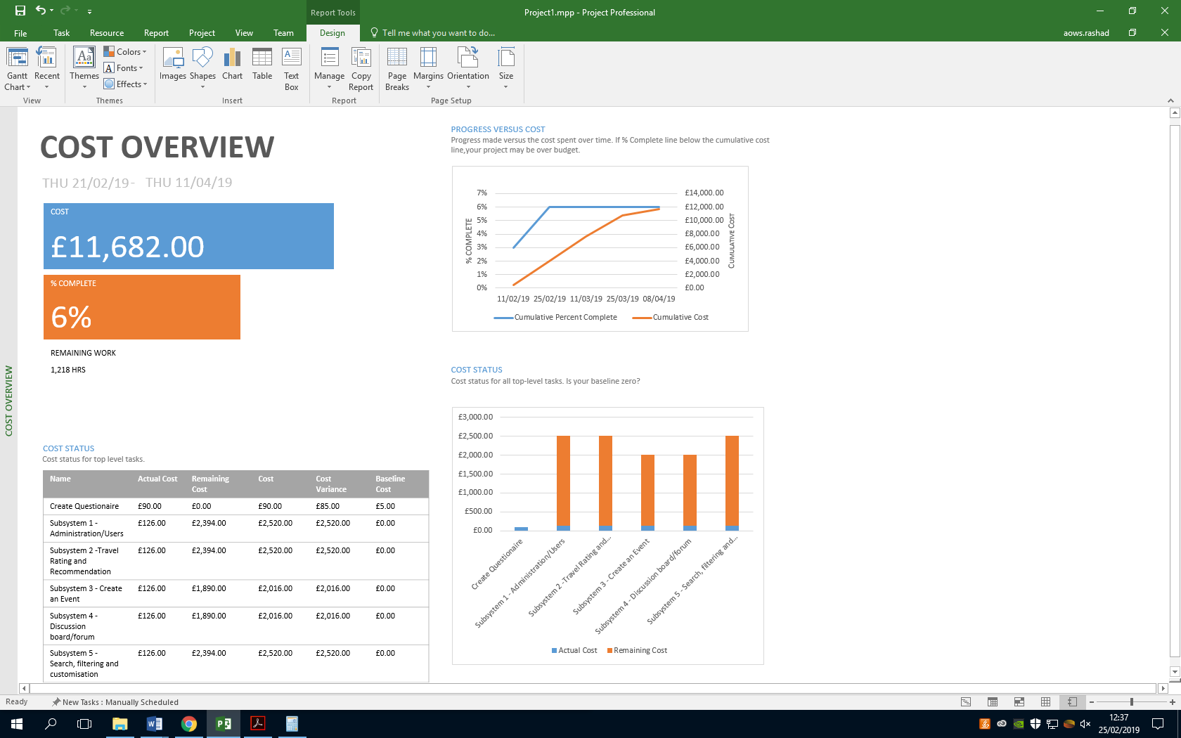

This table shows the top level tasks for the project and provides the cost of how much it would cost for each task/phase.

You can see that the first Column (Actual Cost) is the amount of work which is completed and how much it cost as of then. The second column (Remaining cost) shows how much money it will cost to complete that specific task. The third column (Cost) shows the initial estimation of that task.



This bar chart on the right is another way to represent the cost of each top level task, the orange indicator is the remaining cost of that task and the blue indicator shows how much it has cost so far to complete a small percentage of the project. This bar chart is useful as it can show if the project will go over the estimation after completion.



Finally this represents the total estimated cost of the project which is £11,682.00.

## Domain and hosting cost

To find an estimate I used Amazon Web Services (AWS, n.d.) Calculator to give me and estimated price on running a server instance using their services.

The inputs I requested are for a web server with 1 instance based in North Virginia that will be used for 24 hours/day running Linux on m3.2xlarge which will be paid 1 year upfront.

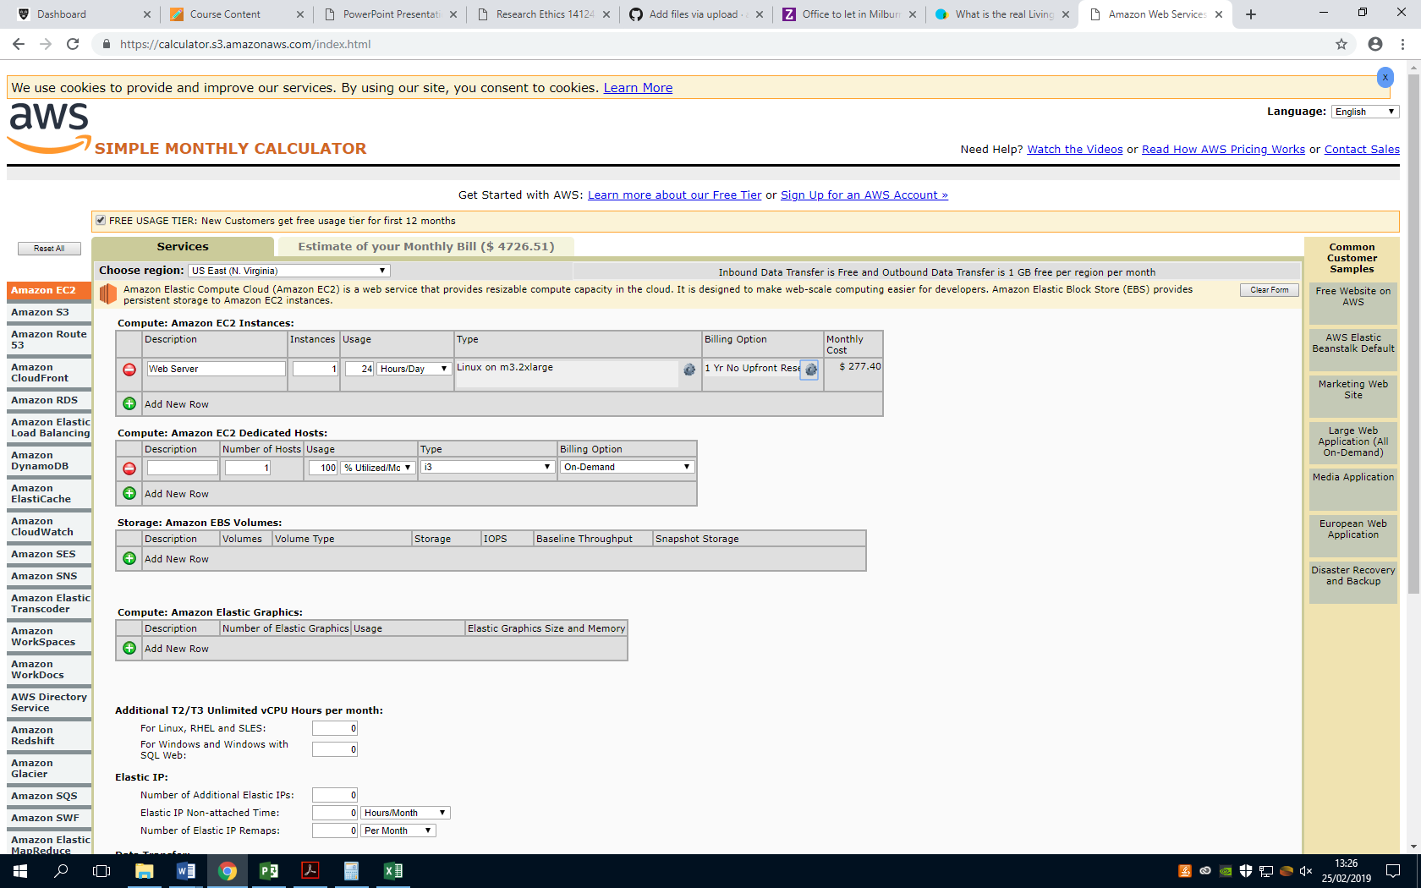

The Linux on m3.2xlarge will have 8 virtual CPU’s (vCPU), 30 GiB memory, 2 x 80GB SSD instance storage and High I/O speeds.

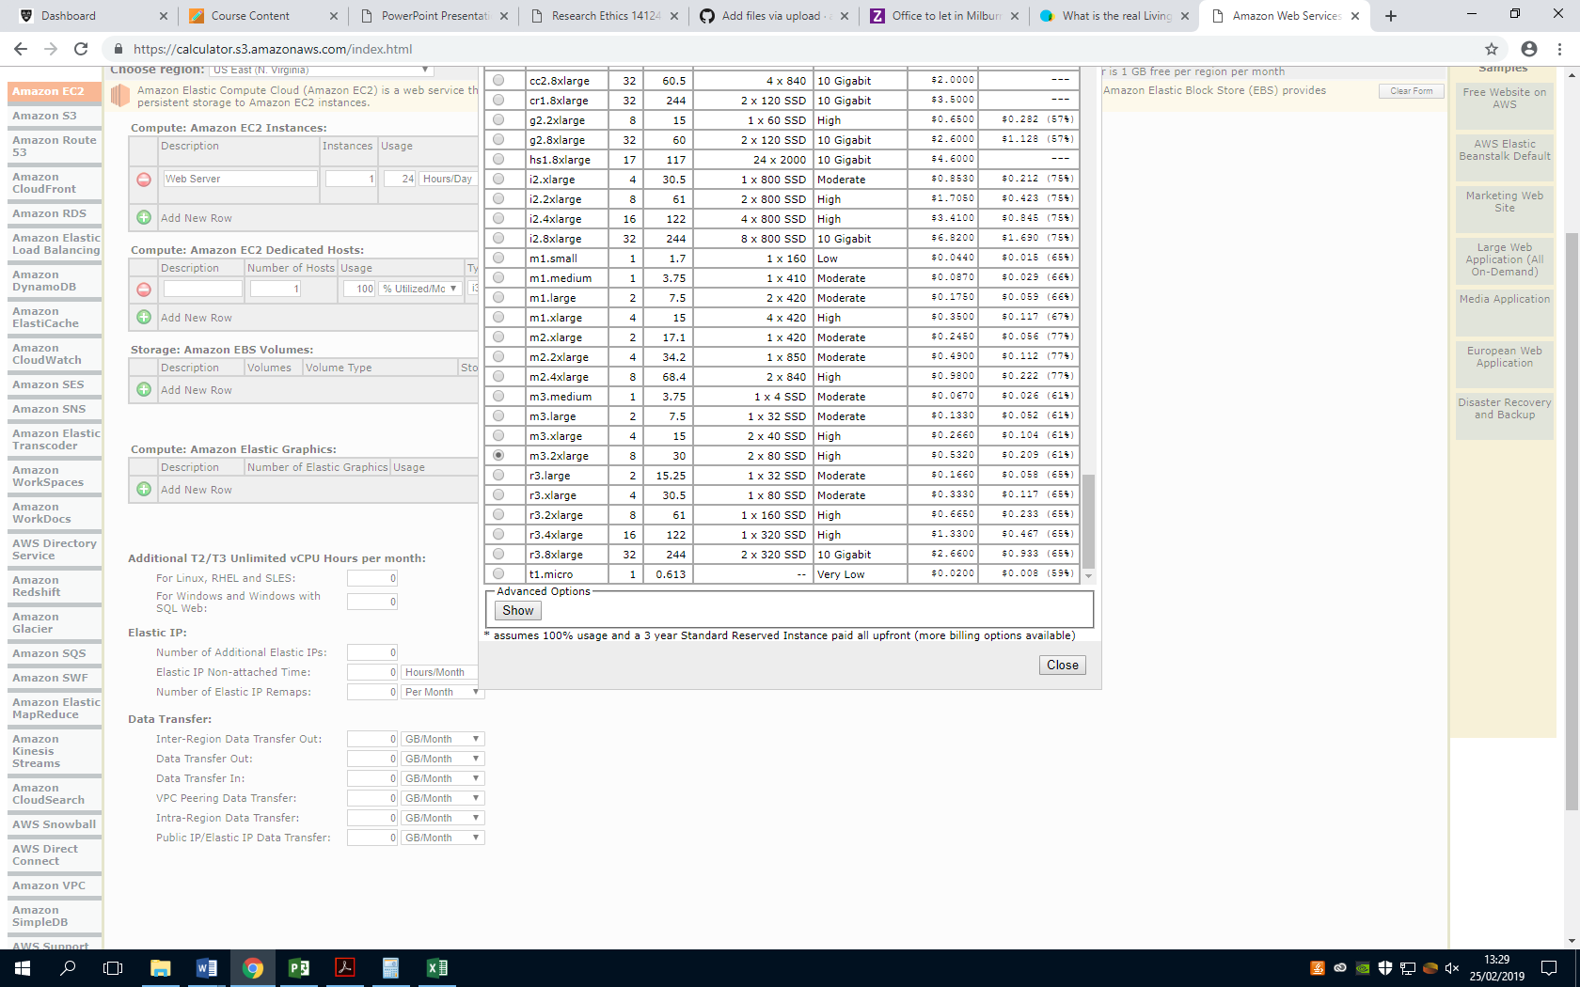



Above is the calculated total monthly payments for hosting a web server on Amazon Web Services

# Conclusion for Project Costing

The estimated premises cost is **£2,419.96** for the entire completion of the project and the estimated cost of employee wages for this project is **£11,682.00** adding these together would give me an overall ballpark estimate for the project. It would cost **£14,101.96** to complete this project and an additional **$4726.51** per month to run the website.

This is however a very rough estimate as unforeseen circumstances can occur that have not been accounted for which can drastically change the outcome of the project. It is however a good idea to create a contingency plan which usually add an extra 5-10% on the budget to finance the unexpected.

# References

AWS. (n.d.). *SIMPLE MONTHLY CALCULATOR*. Retrieved from Amazon: https://calculator.s3.amazonaws.com/index.html

Dowse, M. (2015, February 25). *How much office space per person?* Retrieved from MD Business Interiors: http://www.mdinteriorsdevon.com/how-much-office-space-per-person/

Living Wage Foundation. (2018). *Living Wage Foundation*. Retrieved from Living Wage Foundation: https://www.livingwage.org.uk/what-real-living-wage

Zoopla. (n.d.). *Milburn House.* Retrieved from https://www.zoopla.co.uk/to-rent/commercial/details/34341785?search_identifier=e3a5b56e9dbab27efd3f5491c33237eb

Zoopla. (n.d.). *Office space calculator*. Retrieved from https://www.zoopla.co.uk/commercial/space-calculator/